D3 Layout Tree Extension

QlikView extension for dynamic hierarchy tree display

02-09-2015

Version 1.02

Autor: Renato Vieira

Contents

Description 1

How this extension works 1

How to install 2

QlikView Desktop 2

QlikView Server 2

Extension directory for QlikView Server 3

How to use 3

Configuration 5

Basic tree configuration 5

Layout Configuration 7

Examples 8

# Version History

|  |  |  |
| --- | --- | --- |
| Version | Date | Description |
| 1.0 | 23/01/2014 | Initial Version |
| 1.02 | 02/09/2015 | Added tooltip measure definition to leverage HTML formatting |

# Description

This is an extension that allows dynamic tree representation of an hierarchy in your QlikView application while using the AJAX client. In order to achieve it, D3 library is used. This extension has the following features:

* Display the tree in vertical or horizontal orientation
* Text tooltip for additional info when mouse over the nodes
* Default tree collapse level
* Custom circle configuration for stroke and radius and custom colors for parent or child node representation
* Parent-child links custom layout configuration
* Simple font formatting
* Node selection returned to the QlikView application

# How this extension works

If you are familiar with the Hierarchy() function in QlikView and/or how adjacent nodes tables work, using this extension should be pretty much straight forward to you.

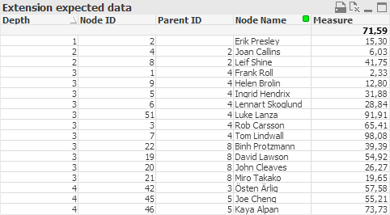

Figure 1: Expected data format

Figure 1 displays the expected data to render the extension. This extension will need to know the *Node ID*, its *Parent ID* and its *Depth*. It will build the tree with that data. It is mandatory that the *Depth* is ordered by numeric value ascending. The Hierarchy() function within QlikView can help you automatically calculate the depth of a node when loading data from your source into your QlikView application. *Node Name* will be the name displayed in the tree. The *Measure* will be used as text for the information available in a tooltip that is presented when hovering the Node.

Besides the *Depth* ordered by numeric value ascending, no further sorting is required. The extension will automatically relate the nodes with their parent and ensure the tree is correctly presented. Without *Depth*’scorrect order, the displayed information will most certainly be faulty and erroneous.

There are two clicking behaviors prepared in this extension:

* If the user clicks on the circle, as a parent node, it will collapse or expand. If it is the last node of the branch (leaf), no action will be done.
* If the user clicks on the text, the selected *Node Name* is returned to the QlikView application.

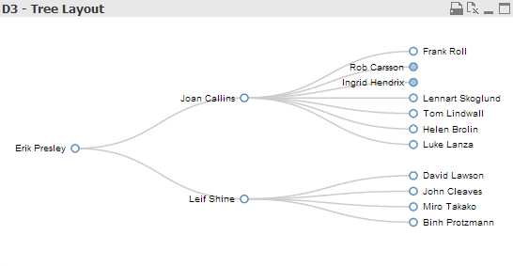

Figure 2: Example of horizontal tree representation.   
Note the blue filled nodes. They represent the collapsed parent.

# How to install

## QlikView Desktop

To install the extension in your QlikView Desktop double click the file ‘D3 - Tree Layout.qar’. Depending on your Windows version it will install the Extension Object in the following directory:

* Windows 2003 – C:\Documents and Settings\[user]\Local Settings\Application Data\QlikTech\QlikView\Extensions\Objects\ D3 - Tree Layout
* Windows 7/2008 –C:\Users\[user]\AppData\Local\QlikTech\QlikView\Extensions\Objects\ D3 - Tree Layout

## QlikView Server

Choose one of the two following steps:

* Browse to the Extension directory for QlikView Desktop, that is listed above in the ‘How to install – QlikView Desktop’ section, and copy the entire ‘D3 - Tree Layout’ folder into the Extension directory for QlikView Server (explained below).
* Change the filename extension from ‘.qar’ to ‘.zip’ of the file ‘D3 - Tree Layout.qar’. Unzip it and copy the entire ‘D3 - Tree Layout’ folder into the Extension directory for QlikView Server (explained below).

## Extension directory for QlikView Server

If this is the first extension to be installed on your QlikView Server instance, the complete directory structure may not exist and will need to be created manually. By default, depending Windows version, the directory structure is:

* Windows 2003 – C:\Documents and Settings\All Users\Application Data\QlikTech\QlikViewServer\Extensions\Objects\
* Windows 7/2008 –C:\ProgramData\QlikTech\QlikViewServer\Extensions\Objects

As another option, you can define an alternate Extension directory path. This is a feature available in QlikView Server v11. You will need to indicate the path of your directory in the QlikView Management Console -> Setup -> QlikView Servers -> <Server Name> -> Folders -> System Folders -> Alternate Extensions Path. Inside your alternate Extension directory path, make sure you create a folder named ‘Objects’ in order to copy ‘D3 - Tree Layout’ folder into it and install the extensions using this alternative path.

# How to use

Right-click on a sheet and select ‘New Sheet Object’.

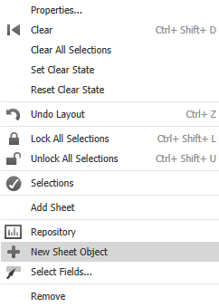

Figure 3: Step 1 to add the extension

Go to ‘Extension Objects’

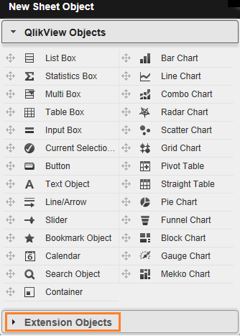

Figure 4: Step 2 to add the extension

and drag the object named ‘D3 - Tree Layout’ to the desired location in the sheet.



Figure 5: Step 3 to add the extension

Righ-click on the caption of the object, select ‘Properties’ and start configuring the object to fit your needs. More detailed information about the possible configurations follows in the ‘Configuration’ section.

# Configuration

## Basic tree configuration

This pane will allow you to identify what fields will be used to build the tree. Please make sure you have read the *‘How this extension works’* section of this document for better understanding of each configurable option in this pane.

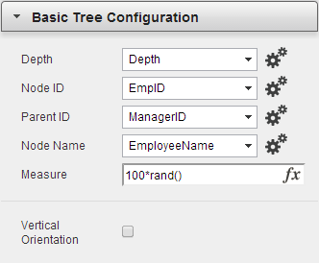

Figure 6: Basic Tree Configuration options pane

* Depth: this is a **mandatory dimension**. Select, within your application, the field that returns the depth of the node[1]. You must set it to order by Numeric Value Ascending as depicted below:

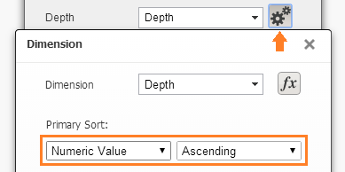

Figure 7: Sort order the value of the node's depth

* Node ID: this is a **mandatory dimension**. Select, within your application, the field that returns the ID of the node.
* Parent ID: this is a **mandatory dimension**. Select, within your application, the field that returns the ID of the node’s parent.
* Node Name: this is a **mandatory dimension**. Select, within your application, the field that returns the name of the node which is to be displayed in the tree.
* 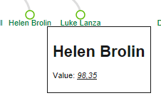Measure: this is a **mandatory expression**. This expression will allow you to send to the extension the granularity level required for its rendering. Calculate it as you normally do with expressions in QlikView. The expression result will display in the tooltip when the user hovers the node with the mouse (check Figure 10 at the end of this document for an example). The whole result will be represented as text and you can combine static text with calculated values. Important: the tooltip’s content is HTML. In other words, it renders HTML tags and formatting that you would generally include in a webpage development. This example

is achieved with an expression like

*'<h1>'&EmpName&'</h1><p>Value:<i><u>'&num(100*rand(),'#.##0,00')&'</u></i></p>'*

* Vertical Orientation: this is an **optional** checkbox. When selected, the tree display will assume a vertical orientation instead of the horizontal default.

Note: Always remember to resize the extension’s window accordingly to the expected number of nodes and depth level. If the extension is not resized correctly some nodes may be drawn outside of the extension’s boundaries and will not display on your application.

## Layout Configuration

In this pane you can fine-tune your tree. You can personalize almost anything: the circles color and size, depth from which the nodes should be collapsed by default, text color and size and link stroke color and width.

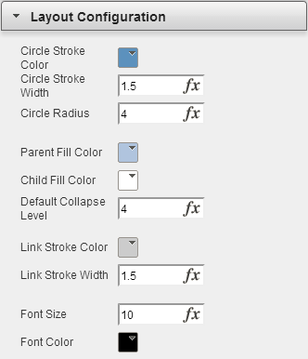

Figure 8: Layout Configuration options pane (default options)

* Circle Stroke Color: this is an **optional** **color box**. Here you can define the color for the circle’s stroke. Either select a color from the available suggestions or type a specific HEX color[2]. All circles share the same stroke color.
* Circle Stroke Width: this is an **optional** **text box**. Here you can define the circle’s stroke width in pixels. All circles share the same stroke width.
* Circle Radius: this is an **optional** **text box**. Here you can define the circle’s radius in pixels. All circles share the same radius.
* Parent Fill Color: this is an **optional** **color box.** Here you can define the color that represents a collapsed node which contains children nodes as well. Either select a color from the available suggestions or type a specific HEX color. All parent nodes will share the same color.
* Child Fill Color: this is an **optional** **color box.** Here you can define the color that represents an expanded node or a leaf node (last node/child of the tree branch). Either select a color from the available suggestions or type a specific HEX color. All parent nodes will share the same color.
* Default Collapse Level: this is an **optional** **text box.** Here you can define the default depth level of which this point and onwards the node is collapsed as default representation.
* Link Stroke Color: this is an **optional** **color box.** Here you can define the color for the radial link line that connects the multiple nodes of the tree. Either select a color from the available suggestions or type a specific HEX color. All link connections will assume the same color.
* Link Stroke Width: this is an **optional** **text box**. Here you can define the linking line between the nodes stroke width in pixels. All link connections share the same stroke width.
* Font Size: this is an **optional** **text box**. Here you can define the font size of the node name’s text. All nodes share the same text font size.
* Font Color: this is an **optional** **color box.** Here you can define the font color for the node name’s text. Either select a color from the available suggestions or type a specific HEX color. All nodes share the same text font color.

## Examples

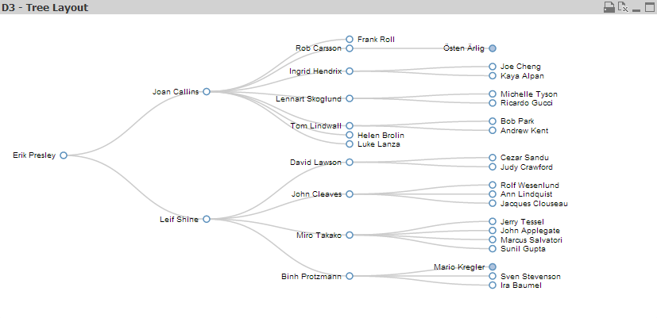

Figure 9: Employee tree example with default extension configurations

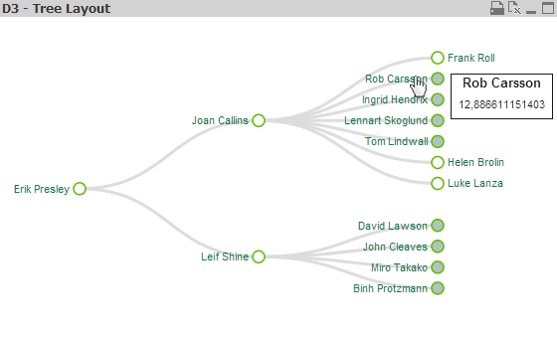

Figure 10: Same tree as Figure 9 with some customizations (circle radius and color, fill color, collapse nodes from the 3rd depth level, font color and size) and a mouse hover tooltip example.

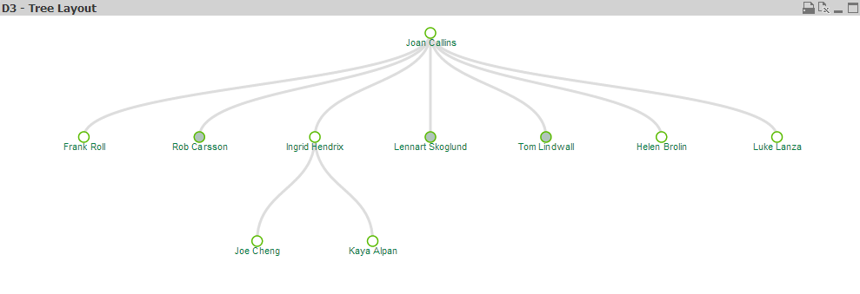

Figure 11: Same configurations as Figure 10 with added vertical orientation and only a few nodes selected in QlikView

1. When loading your adjacent nodes table into your QlikView application, consider using the Hierarchy() function. It can store in a field the depth of each node. For more information check the help of QlikView Desktop.
2. For more information about Hex colors: <http://en.wikipedia.org/wiki/Web_colors#Hex_triplet>